Association Sport for all Serbia
Montenigrin Sport for all Association
 | Application form
 |  | -35 | +35
1 | Mini football (5+1) (M)
2 | Basket, team of 3 players (M)
3 | Basket, team of 3 players (F)
4 | Volleyball, mix 4+2
5 | Beach vollyeball, mix 3+1
6 | Table tennis, mix 2+1
7 | Shooting, mix, 3+1
8 | Archery, M/F
9 | Chess, team of 4 players
10 | Darts, team of 4 players (M)
11 | Darts, team of 4 players (F)
12 | Tug of war, mix 4+2
13 | Water Triathlon M/F
14 | Badminton, mix 1+1
15 | Traditional games M/F
16 | Foot-tennis, mix 1+1
Name of the team:_______________________________
Contact person:____________________________,
tel______________________________
Let fest 20-24.09.2017.
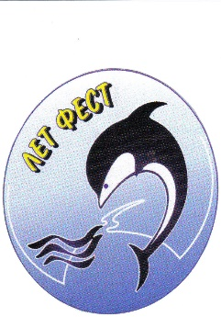
Open SUMMER FEST Sport for All
SUTOMORE, Montenegro 20-24.09.2017.

Country
Name of organization
Address
Tel Fax E-mail
We would like to be accommodated in:
Double room , single room

