International Sport and Culture Association
Tietgensgade 65
DK-1704 Copenhagen V
Denmark
Vejle 22 August 2013
Nomination of Mogens Kirkeby as President
On behalf of DGI I nominate Mogens Kirkeby as President of International Sport and Culture Association (ISCA).

During his presidency ISCA has developed into a significant political factor in European sports policy and in the global sports scene in general. Furthermore Mogens has managed to enlarge the network of ISCA, and has developed partnerships with strong political, financial and media partners.

Mogens is a leader with strong views and a clear vision. He combines organizational experience with political commitment in a unique way.

I can give Mogens my warmest recommendations.

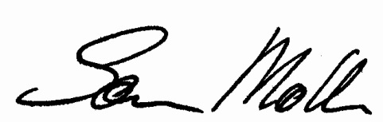
Sincerely

Søren Møller
President

