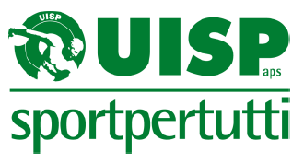

Motivation Letter – Candidature ISCA Executive
My name is Daniela Conti and I work for UISP (Italian Sport for All Association) since 1995 in different areas: sport in prison, European projecting, football fans culture, antidiscrimination and sport, international cooperation and international relationship. I have a degree in Sociology and I was always interested in sport as social phenomena, of course I also do lot of sport!
Actually, I am responsible for UISP Policies for Interculturality and Cooperation.
In my opinion sport could be a real tool for social inclusion and for breaking wall, especially in a period where many politicians want to build wall to top people moving and finding new life. History teaches us how dangerous is the fear: be afraid of diversities, of culture or religion far from our… this has provoked (and still does) hates and wars. Sport has always had a special power if used in the correct way: it is a nonverbal language, it produces joy, it is an educational tool, it makes people in good mood and promote healthy life style. Of course, sport is not good for itself, it depends always from the value prompted by the association.
We have example of sport used as far right propaganda or as something to be banned for certain people (women, disabled, elderly people). So, it depends from us transform this fantastic tool in something alive.
UISP since its born has worked and used sport as an opportunity for working with the most marginalised people: sport in prison, in the refugees’ camp, for women freedom, for LGBTQI+ equal rights, for people with disabilities. I’ve got a great opportunity in my life to work for great projects such as Mondiali Antirazzisti, World Social Forum, projects in Lebanon and Senegal, projects in the prisons of Rome. I am also a volunteer in a local sport club Liberi Nantes who since 2007 is engaged in the difficult struggle to break the wall of discrimination in sport for refugees, asylum seekers and migrant of second generation.
I learnt a lot from all the people I have the chance to work with: managers, athletes, common people from each culture, sex, orientation and religion and I really understand the big power we have in our hands.
Sport is also a fantastic pill against sedentary lifestyle and the consequent risk for our health. I really believe a correct life style can contribute in improving life condition of all the people in the world and for the elderly people can contribute in their dignity in the senile age, where some diseases have the power to switch off step by step brilliant mind.
I know Isca and its campaigns and projects since many years and I really believe in the necessity of an international organisation composed by different souls, colours, cultures and visions, in order to improve our knowledge and skills.
Especially in this moment, where the pandemic teaches us once again how much interconnected we are and how much important could be to work united, I think we really need to find field of comparison, mutual learning and common work in order to promote a more equal society. This pandemic, the recent wars or “post-conflict” situation, the flow of migrants running away from horror, the warning of Fridays for Future, should be a boost to think new projects, new actions and new activity of advocacy towards the national and international government to hear the voice of the voiceless. Sport can help in this with its project, its strength and its capacity of aggregate people.
In the end, considering the fact that in the last part of my life I discover the cyclo-tourism I hope to start this new journey in the Isca executive committee, that as each good route it will be composed by hard ups and easy downs, but each fatigue will be repaid by the wonderful travel and the very good company.

Faithfully,
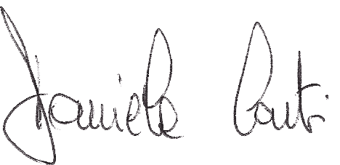
Daniela Conti

